THE GLOBAL DAY OF GENEROSITY
COMPLETE GUIDE FOR NONPROFITS, NGOs, CSOs, + COMMUNITY ORGANIZATIONS

GivingTuesday: December 3, 2023

@givingtuesday givingtuesday.org

Introduction
How Nonprofits + Community Organizations Can Participate in GivingTuesday
Key Messages
How to Reach New Donors on GivingTuesday
Getting Your Social Channels Ready
Other Digital Tactics
Sample Campaign Timeline
Social Media Ideas for GivingTuesday
What to Do On Your Organization’s Social Pages
What to Encourage Others to Do On Their Social Pages
Sample Social Media Messages
Email Templates
Sample Press Release
How to use this template:
FAQ for Nonprofits

Introduction
GivingTuesday is an opportunity for people around the world to use their individual power of generosity to support their communities.
On GivingTuesday – December 3, 2023 – the whole world comes together to give back in many different ways: through acts of kindness, gifts of voice, time, talent, or treasure. Nonprofits can leverage the energy of GivingTuesday to tell their stories, engage lifelong advocates, and build an active community to support their missions.

This guide provides some ideas and basic organizing tactics you can use to rally support for your cause on GivingTuesday. Make sure you’re signed up for our email list to receive new resources, news, and ideas for how to grow generosity.

How Nonprofits + Community Organizations Can Participate in GivingTuesday
GivingTuesday is among the few days of the year where people are actively seeking causes to support, rather than the other way around. On December 3, 2023, the entire world will be talking about, thinking about, and discussing ways each of us can contribute to a better society. Nonprofits have an amazing opportunity to be part of that conversation.

How you choose to participate in GivingTuesday is up to you! While many nonprofits fundraise on GivingTuesday, that’s not the only option. The goal is to create an activation that allows people to express generosity in a memorable, impactful way. Here are a few ideas:
- Host a holiday food drive for your community, fill a gap in services, or solve an immediate need in your community.
- Host a festival so that local residents can learn about the missions of several organizations. Consider leading a GivingTuesday Community movement!
- Use the day to rally new volunteers.
- Mobilize your community to give their voice to your cause – whether that involves signing a pledge, advocating for policy change, or simply getting the word out about your cause.
- Fundraise for your organization.
- Fundraise for another organization. Give your megaphone to amplify historically under-funded organizations.
- Find ways to collaborate with others. Our community is bigger than just one organization and we are not competitors. It will take all of us to work together to build the just + generous world that we seek.
- Spend GivingTuesday thanking and celebrating your supporters.
- Find more creative ideas for growing generosity in your community in the Generosity Toolbox!

Key Messages
How to talk about GivingTuesday 2023
- GivingTuesday is a global generosity movement, unleashing the power of people and organizations to transform their communities and the world.
- While GivingTuesday happens every Tuesday, the annual celebration of generosity will happen on December 3, 2023.
- GivingTuesday was created in 2012 as a simple idea: a day that encourages people to do good. Over the past 11 years, this idea has grown into a year-round global movement that inspires hundreds of millions of people to give, collaborate, and celebrate generosity.
- People can show their generosity in a variety of ways during GivingTuesday⁠⁠—whether it’s helping a neighbor, advocating for an issue, sharing a skill, or giving to causes, everyone has something to give, and every act of generosity counts.
- Generosity gives everyone the power to make a positive change in the lives of others and is a fundamental human value anyone can act on.

Note
“Signing Up” For GivingTuesday
There’s nothing to sign up for! No matter how you’re planning on participating on Dec 3, you’ll simply direct your supporters to your website, a landing page, or to your social channels. If you are fundraising for GivingTuesday, you can use any donation platform you like - most organizations use their website’s donate button.

Be sure to check if your country or city has an official GivingTuesday campaign - some local GivingTuesday movements do have a registration process. Start by checking out the GivingTuesday website for your country.

On “Donor Fatigue”
Our research suggests that people are very motivated to give to many different causes. The key right now, as at any time, is ensure your relationship with supporters is experiential rather than transactional.

We find that people want lots of ways to show support for the causes they care about, and on GivingTuesday, the vast majority of donors also take some other action. Providing multiple touch points, messages and opportunities to show support helps make you relevant and inspiring.

We believe, and our data show, that "donor fatigue" is a function of the quality of the message and engagement rather than a question of frequency. Think about how your organization is providing supporters with an opportunity to exercise their generosity and agency to make positive change - that approach will help focus engagement that is motivating.

How to Reach New Donors on GivingTuesday
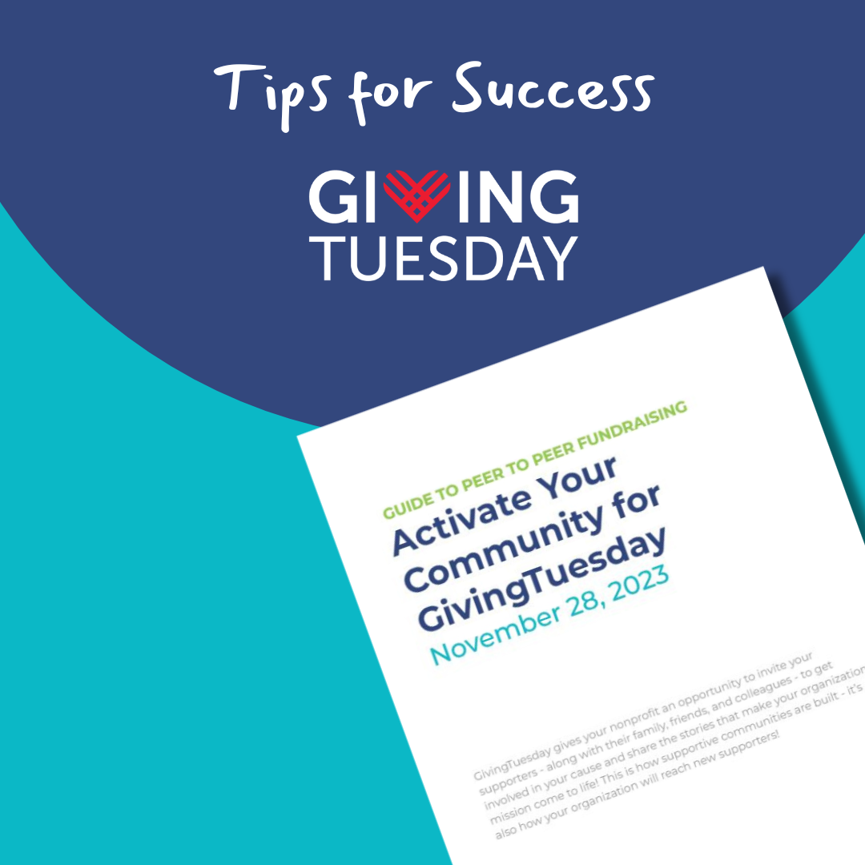

GivingTuesday gives your nonprofit an opportunity to invite your supporters – along with their family, friends, and colleagues – to get involved in your cause and share the stories that make your organization’s mission come to life! This is how supportive communities are built – it’s also how your organization will reach new supporters!

GivingTuesday presents a unique chance for nonprofits to expand their networks and reach new supporters. By harnessing the power of your existing network, you can cultivate a community of like-minded individuals who are ready to stand alongside you in your mission throughout the year and jump into action whenever needed.
For smaller nonprofit organizations, this approach significantly streamlines the process of organizing a GivingTuesday campaign, as your most dedicated ambassadors take the lead.

Access the P2P Toolkit here

Getting Your Social Channels Ready

- Make sure your social pages show your organization in its best light. You’re going to have lots of new people looking at your profile pages. Can they easily discover your impact within the first few seconds of scrolling? Make sure you’re posting often over the next few weeks about your organization and its impact.

    - Pin highlight stories to the top of your Instagram page that explain what you do and how to get involved in your mission
    - Pin your top 3 posts to your feed on Instagram and TikTok that highlight very clearly what it is that you do
    - Pin 1 post to your Twitter and Facebook pages that clearly explains what you do and the kind of help you need to keep doing that work.
    - Launch a group or broadcast channel. Now’s a great time to launch a virtual group to build your community – people are craving a sense of togetherness. Consider a WhatsApp group for your top donors, a Facebook group for your p2p fundraisers, or an Instagram close friends list for influencers to repost your content to their own feeds.
    - Start planning for how you’ll show up virtually on Dec 3. (Find ideas below)

Other Digital Tactics
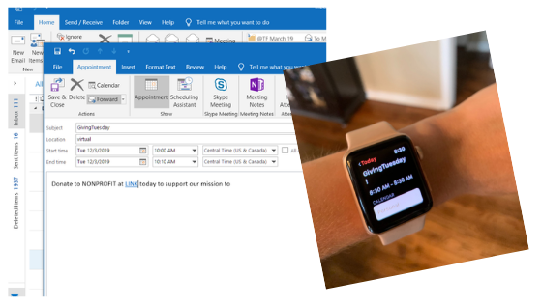
- Send your supporters a calendar invite. Literally. Attach an .ics calendar invite file to your email (or use something like Add Event). You should provide exact instructions for what you’d like them to do on GivingTuesday including a link if you want them to donate.
- Start a series of emails to build up anticipation of the big day. One a week to start, then build as the days get closer.
- Over the Thanksgiving holiday make sure your staff’s email auto-responder mentions your upcoming GivingTuesday campaign with instructions for how to participate!
- Did you know that each year, an estimated $4-7Billion USD is in corporate matching gift funds goes unclaimed? Make sure you ask your donors if their employers will match their donations to your cause!

Sample Campaign Timeline

Summer/Early Fall 2024

- Decide how your organization will participate in GivingTuesday.
- Set a goal and consider your target audience. Would you like to recruit more volunteers? Get more social media followers? Raise money for your cause? Partner with your community to solve a specific issue? However you decide to participate in GivingTuesday, set a goal and give your staff and community something to aim for.
- See if your country or city is planning a local campaign for GivingTuesday. If there’s a local movement, reach out to their team to see how you can get involved. If there’s not, that’s ok (but you should consider leading one for your community next year!)
- Email your supporters to share that your organization is participating in GivingTuesday and share a calendar invite. (You can send this link or create your own with AddEvent so that you can add your organization’s donation page).
- Rally your team of ambassadors and ask them to run P2P fundraisers on behalf of your organization. Here’s how to plan a successful P2P campaign.

First Week of November

- Announce. Share your plan and goal in a press release or host a virtual community launch party, and start spreading the word about your plans for GivingTuesday on social media.
- Build a drumbeat. Schedule regular social media messages to talk about your organization’s work and how your community can best support your mission.
- Think about a match or other challenge. If you are organizing a fundraising campaign, talk to supporters about providing a match or challenge grant to build extra excitement on GivingTuesday.
- Email your supporters again to remind them that GivingTuesday is coming and specific details about how they can get involved. Check out the sample emails below.
Second Week of November
- Announce. Share your plan and goal in a press release or host a virtual community launch party, and start spreading the word about your plans for GivingTuesday on social media.
- Build a drumbeat. Schedule regular social media messages to talk about your organization’s work and how your community can best support your mission.
- Think about a match or other challenge. If you are organizing a fundraising campaign, talk to supporters about providing a match or challenge grant to build extra excitement on GivingTuesday.
- Email your supporters again to remind them that GivingTuesday is coming and specific details about how they can get involved. Check out the sample emails below.

Third Week of November

- Go big on social media! Stay top of mind: invite your community to join with you on December 3. Remember to use the hashtag #GivingTuesday in your messages so we can retweet and share your plans. Make use of your social media scheduling tools!
- Schedule a few emails during the week and over the weekend to remind your supporters that the big day is coming.
- Remind Black Friday and Cyber Monday shoppers to save some energy for GivingTuesday.
- Remind your ambassadors and P2P fundraisers that there’s 1 week to go, re-up your toolkit, and thank them in advance.

December 2 (Day Before)

- Send a “1 Day to Go” email and social media messages.
- Make sure your board, staff, p2p fundraisers, and larger community know that we are in the final countdown for GivingTuesday!

December 3 (GivingTuesday)
- It’s GivingTuesday! Remember to update your community about your campaign throughout the day. Share where you are against your goal and use the buzz and momentum from the day to build excitement for your campaign. Thank donors and people who are helping to amplify your campaign.
- Post on social media all day long. Go live, share a photo every hour (no need to create anything new, reuse your existing content), and highlight stories of generosity from your community. Talk about how critical your mission is and how your organization is working to create change in your community.
December 4
- Send a personalized thank you to your staff, donors, volunteers, partners, and community.
- Post some #ThankYouWednesday posts on social! Celebrate your community of clients, volunteers, staff, and supporters.
- Share your success with us! Email the GivingTuesday team at info@givingtuesday.org with your success, photos, or announcements we can share.
- Use the momentum from GivingTuesday to boost your end of year fundraising and rally further support for your mission.

Social Media Ideas for GivingTuesday

What to Do On Your Organization’s Social Pages
- Spend a lot of time in Stories – most users are hanging out here versus scrolling their feeds. Ideas:
  - Share what a day is like at your organization,
  - Share what a day is like for someone you serve,
  - Share your organization’s progress in fixing the systemic issue that you’re working on tackling.
  - Create an interactive quiz to educate people on your cause area
- Focus on Reels and TikTok: these are the only two social media mechanisms that are designed to help you reach new followers.
  - Here are 13 Reels Ideas for Nonprofits from Community Boost
- Produce a livestream conversation about your mission on Facebook or YouTube.
- Post photos and videos that tell your story – not graphics. Visual content like photos and videos evoke stronger emotions than static graphics. When people see the real impact of your work, they can empathize with the individuals or communities being helped, making them more inclined to contribute.
  - A note on why we’re no longer encouraging graphic flyers: when we all post the same graphics, the algorithms “throttle” that content down. We really need to be creating our own content. The GivingTuesday Canva templates still exist but please understand that nonprofits need to be creating their own custom content to appeal to their supporters.

What to Encourage Others to Do On Their Social Pages
- Organic reach is down but you can get around that by asking your community to post on your behalf to their social media channels!
- Encourage your supporters to share why they support your cause
- Organize a challenge (on TikTok or Instagram Reels)! Encourage your partners and friends to spread generosity on social media by getting creative.
- Get a vendor or small business to sponsor a social media contest to benefit your organization.
- Empower your supporters to run a P2P fundraiser on behalf of your organization. Here’s how.
- Ask if your supporters would consider matching donations made by their friends and family.
- Ask your supporters to share what they’ve been doing to spread generosity in their local communities. Whether or not that has to do with your cause. Let’s overwhelm the world with GOOD.

Sample Social Media Messages
We’ve ditched the copy-paste social media posts because, let’s face it, algorithms just don’t like them anymore. It’s substantially more effective to create content that speaks directly to your audience. Here are some ideas to help you kickstart your content game:

- Save the Date Post: A post announcing the date of GivingTuesday, inviting followers to mark it on their calendars and stay tuned for upcoming details about how to participate. Use Instagram’s “reminder” feature or link to a calendar invite.

- Impact Showcase: Photos showcasing the real-world impact of your work, sharing success stories, and emphasizing the importance of continued support.

- Why We Need You: Videos explaining the specific challenges your nonprofit is facing and why your community’s support is crucial to overcoming those challenges.

- How Generosity Helps Your Nonprofit Make Change in the World: Tell stories about how generosity is critical in helping you achieve your mission.

- GivingTuesday Sneak Peek: Teaser posts offering a glimpse of the exciting initiatives, events, or campaigns the nonprofit has in store for GivingTuesday.

- Community Voices: Posts featuring stories and testimonials from members of the community including the people you serve, sharing why they support the nonprofit’s mission and encouraging others to do the same.

- Call to Action: Posts providing a clear and concise action plan for GivingTuesday, outlining the various ways followers can get involved and make a positive impact on the day.

Email Templates

To Supporters - Save the Date

Subject Line: Join Us for GivingTuesday - the Global Day of Giving on Dec 3, 2023

On December 3, 2023, people all around the world are coming together to tap into the power of human connection and strengthen communities and change our world. Will you be one of them?

[Name of organization] will be participating in GivingTuesday and we need your help!

By joining the GivingTuesday movement, you’re proving that in times of uncertainty, generosity can bring the whole world together.

Here is how you can get ready to give:

- Mark your calendar [Link to a custom calendar invitation for Dec 3 that includes your organization’s donate link]

- Give. On December 3, go to [insert your organization URL] and donate. You can also support our organization in these ways [insert link to a blog post that outlines other needs like a wishlist, virtual volunteer opportunities]

- Spread the word. Encourage your friends and family to join you in creating real impact on December 3 by sharing what our mission means to you and why you support our organization (here are some ideas). Make sure to use hashtag #GivingTuesday and tag us so we can share!

Let's rally together to build stronger communities.

Learn more at [insert your organization URL]

To Board Members in advance of the campaign
Subject line: |*FNAME*|, we need your help!

Hi [board member name],

GivingTuesday is only [x] days away and [organization name] is starting to plan our big celebration. This is a big day for us, we’re aiming to raise [insert goal or a line about how much you raised last year or how you’re using the day to go big on your kick off for end of year]. This is where you come in. We’re asking all of our board members to help us rally our community and maximize GivingTuesday. Here are some ways that you can help.

- We’ve set a goal to achieve 100% giving by board members on December 3. [Reminder about give/get if applicable]
- Help us organize matching funds for our organization. Matching funds provide great incentives for both new and existing donors and motivate them to act fast to double their impact on our cause. You can help by contributing to our matching grant pool and asking your networks to contribute too. [Insert some more info about who you’ve reached out to already and some of your ideas about how you’ll organize your match]
- Help us spread the word. Here’s link to a Google Drive with sample emails you can send to your friends and family and sample social media messages for LinkedIn or Facebook. Personalize these messages and share why our mission matters so much to you!
      - Please also consider fundraising on our behalf. [insert information about your p2p program]

Thank you, [Name], for your ongoing commitment to [mission]. We simply could not do this without you. Please contact us if you have any questions or need any assets to help with your outreach. Thanks in advance for making GivingTuesday 2022 our best yet!

Sincerely,
[Name][Title]{Org}

To Supporters - Give Today

Subject line: Together we can

In this time of uncertainty, there's a fundamental truth that gives us hope - that together we can do extraordinary things. Whether that's through donations to community organizations or reaching out to a neighbor to help with groceries, generosity has been helping the entire world get through this global pandemic. Together.

{ORG] is participating in GivingTuesday today, the global day of unity and giving. As you know, our organization [Describe in 2-3 lines the critical work your organization is doing in your community and how your nonprofit will be participating]

But we can’t do this without you!

Not only do we need your support, we need your help to spread the word. Please tell your friends and family why you believe in our work and encourage them to support us too!

Join the movement today! [Insert bullet points for how supporters can contribute, details about any special plans you have for today, including links to livestreams, donate pages, social media challenges, etc.]

Thank you for being a part of the [Organization] team. Together we can [insert your mission].

Name
Title
Organization

Sample Press Release

How to use this template:
- Add your campaign details (as much as you know right now and you don’t have to have everything set) in the press release template below.
- Be sure to have someone in the contact space who is readily available and responsive
- Add a campaign name and details of how you want the public to engage in the day.
- Circulate to your press outlets and include the release as a blog on your website and promote socially. Edit so that it makes sense for your community.
- Here are some tips from Joan Garry on securing press coverage.

Contact:
[CONTACT NAME]
[CONTACT ORGANIZATION]
[PHONE]
[EMAIL]

[INSERT ORGANIZATION NAME] Celebrates GivingTuesday with [INSERT CAMPAIGN DETAILS], joining millions around the world participating in the global generosity movement on December 3, 2023
[INSERT LOCATION] [INSERT DATELINE] – This GivingTuesday, [INSERT ORGANIZATION NAME] will inspire generosity by [INSERT TOPLINE DETAILS OF CAMPAIGN].
GivingTuesday is a global generosity movement, unleashing the power of people and organizations to transform their communities and their world. GivingTuesday will kick off the generosity season this year by inspiring people to give back on December 3, 2023, and throughout the year.
[ WHY YOUR ORGANIZATION JOINED GIVINGTUESDAY AND DETAILS OF YOUR INITIATIVE INCLUDING GOALS, PARTNERS AND PAST SUCCESS, IF APPLICABLE]
[INSERT QUOTE FROM YOUR ORGANIZATION’S SPOKESPERSON ON THE ORGANIZATION’S GIVINGTUESDAY EFFORTS]
GivingTuesday was launched in 2012 as a simple idea: to create a day that encourages people to do good. Over the past eleven years, this idea has grown into a global movement that inspires hundreds of millions of people to give, collaborate, and celebrate generosity.
People demonstrate generosity in many ways on GivingTuesday. Whether it’s helping a neighbor or stranger out, showing up for an issue or people we care about, or giving to causes we care about, every act of generosity counts. GivingTuesday has raised billions of dollars for critical causes around the world and gets 21 billion impressions on social media from people and organizations speaking up for the causes that matter to them and encouraging others to get involved in their communities.
"GivingTuesday inspires people all around the world to embrace their power to drive progress around the causes they care about, not just on one day but throughout the year." said Asha Curran, GivingTuesday’s CEO, and co-founder. "With country and community leaders, millions of organizations, and countless givers of all kinds, GivingTuesday is creating a shared space where we can see the radical implications of a more generous world."
Those who are interested in joining [INSERT ORGANIZATION NAME]’s GivingTuesday initiative can visit [INSERT URL]. For more details about the GivingTuesday movement, visit the GivingTuesday website (www.givingtuesday.org), Facebook page (https://www.facebook.com/GivingTuesday) or follow @GivingTuesday and #GivingTuesday on Twitter.

About [INSERT ORGANIZATION NAME]
[INSERT ORGANIZATION BOILERPLATE]

About GivingTuesday
GivingTuesday is a global generosity movement unleashing the power of people and organizations to transform their communities and the world. GivingTuesday was created in 2012 as a simple idea: a day that encourages people to do good. Over the past ten years, it has grown into a global movement that inspires hundreds of millions of people to give, collaborate, and celebrate generosity.
Whether it’s making someone smile, helping a neighbor or stranger out, showing up for an issue or people we care about, or giving some of what we have to those who need our help, every act of generosity counts and everyone has something to give. GivingTuesday strives to build a world in which the catalytic power of generosity is at the heart of the society we build together, unlocking dignity, opportunity and equity around the globe.
###

FAQ for Nonprofits

What is GivingTuesday?
- GivingTuesday is a global generosity movement that unleashes the power of people and organizations to transform their communities and their world.
- GivingTuesday was created in 2012 as a simple idea: a day that encourages people to do good. Over the past eleven years, this idea has grown into a global movement that inspires hundreds of millions of people to give, collaborate, and celebrate generosity.
- GivingTuesday strives to build a world in which the catalytic power of generosity is at the heart of the society we build together, unlocking dignity, opportunity, and equity around the globe.
- GivingTuesday’s global network collaborates year-round to inspire generosity around the world, with a common mission to build a world where generosity is part of everyday life.

When is GivingTuesday?
- GivingTuesday is held annually the Tuesday after Thanksgiving and this year on December 3, 2023. It’s held on the same day in most participating countries in the world.

Who is organizing this?
- GivingTuesday is a nonprofit organization that is dedicated to unleashing the power of people and organizations to transform their communities and the world. The movement is organized in partnership with GivingTuesday’s global network of leaders, partners, communities and generous individuals.
- GivingTuesday’s ultimate goal is to create a more just and generous world, one where generosity is at the heart of the society we build together, unlocking dignity, opportunity, and equity around the globe.

Who can participate?
- Everyone! GivingTuesday has been built by a broad coalition of partners, including individuals, families, nonprofits, schools, religious organizations, small businesses and corporations. There are people and organizations participating in GivingTuesday in every country in the world.
- Participating in GivingTuesday is about joining a movement for generosity, and there are so many ways to do that. Whether you give your voice, goods, your time, or your money, being generous is a way to fight for the causes you care about and help people in need.

How can people participate in GivingTuesday?
- Participating in GivingTuesday means that you’re joining a global movement for generosity and there are so many ways to do that. Whether you give your voice, goods, your time, or your money, being generous is a way to fight for the causes you care about and help people in need.
- Connect with your local GivingTuesday movement to learn more about how you can give back in your country or U.S. community.
- Here are some ideas you might consider:
  - Share kindness with your neighbors.
  - Volunteer virtually or share your talents
  - Give your voice to a cause that matters to you
  - Discover a local fundraiser, community drive or coordinated event to join others in your area or with your same interests in giving back -- they need your help. Search for opportunities here
  - Give to your favorite cause or a fundraiser to help those in need.
  - Use social media to spread the word!
    - Talk about giving and generosity using the hashtag GivingTuesday
    - Share our Facebook posts — facebook.com/GivingTuesday
    - Follow us on Twitter @GivingTuesday and use the #GivingTuesday hashtag
    - Follow us on TikTok— GivingTuesday
    - Instagram — givingtuesday
    - Snapchat — add/GivingTuesday
    - Share our social media channels in your organizational and personal social networks
  - Announce your participation in GivingTuesday to your networks and email lists
  - Visit our website for more ideas and ways you can get involved.

What does it cost to participate?
- There are no costs to participating in GivingTuesday. GivingTuesday is a free and open movement to unleash generosity and all of our resources are available for free through our website.
- If your nonprofit is using a digital fundraising platform, there may be costs associated with the tools you choose to use – check with your technology providers to learn more - these will be the same costs that occur on any other day of the year.

Does GivingTuesday raise money or collect fees on GivingTuesday?
- No, all fundraising activities and the funds raised on GivingTuesday are directed by each participating nonprofit organization and processed by the giving platform of their choice.

I want to give back, help my neighbors and volunteer, but how can I do that safely?
- GivingTuesday is focused on ways to give back and bring communities together safely. We encourage individuals and organizations to adhere to public health guidelines and physical distancing to help reduce the spread of the virus and flatten the curve.
- There are many ways people can give back and communities can organize while still staying safe. Here are some ideas.
- There is no reason that our physical separation means we can’t provide the financial, emotional and social supports that nurture our families and communities. We all have gifts to give, and with social media, online giving, delivery, mail, and phones, there are limitless ways to use your generosity to support others. Embrace your power to be a beacon for others, and act.
- For more ideas, visit our website or sign up for GivingEveryTuesday to get ideas and inspiration each day for ways to show kindness and give back while staying safe.
- GivingTuesday will share specific opportunities for individuals to participate in local, regional and country campaigns as well as ideas they can take and use for individual action or to rally their family, friends, neighbors, coworkers and networks to do good.

Can I still give even if I don’t have any money?
- Yes! If you are an individual who wants to give back, there are many ways to do so. GivingTuesday is about giving of all types -- some may choose to give a financial contribution to their favorite cause or a fundraising drive, others will opt to reach out to neighbors, start an advocacy campaign, donate goods or extra supplies, share gratitude to frontline workers and those keeping us safe. If you can show generosity and share kindness, you have something to give!

How can nonprofits + community organizations get involved?
- As a nonprofit or community organization, you can decide how much you’d like to do during GivingTuesday and what type of activity you’d like to organize. Some organizations host fundraising events while others use the opportunity to reach out to their community with special content, a volunteer event, or to thank their donors.
- Organizations do not receive donations through the GivingTuesday website. All donations need to be made through your organization’s donation processing platform of choice. You can choose whatever platform you’d like to use. Note: If you’re intending on participating in one of the matching grant programs that happen on GivingTuesday, please read the rules carefully- each program requires use of a particular platform in order to track results. Check directly with whoever is running that match program for details.
- One great way organizations can help is to spread the word and encourage your communities and supporters to take action and do good on December 3. Use the hashtag #GivingTuesday when you post on social media so we can amplify your message.
- If you are part of a network or lead a group, think about ways you can rally around a cause and encourage your group to perform acts of kindness and generosity on this day. Share the ideas from our toolkits with your colleagues and decide if there’s a particularly relevant type of activity that showcases your industry, interest, skills or other unique assets

Questions?
Have questions about GivingTuesday or want to tell us about what you’re planning?

- If you’re a nonprofit in the U.S., be sure to check out the nonprofit hub page for case studies, ideas, and more.
- If you’re an organization outside of the U.S., please connect with your local GivingTuesday
- Contact the team: info@givingtuesday.org
- Join the GivingTuesday Facebook group for nonprofits
- Make sure you’re on our newsletter list so you get the latest information on upcoming events, webinars, and opportunities.

More Resources
Make sure you’re on the GivingTuesday email list to receive the latest news, upcoming events and opportunities! We also invite you to join the GivingTuesday Learning Lab on Facebook and collaborate with organizations from all over the world.

Case studies about how nonprofits participate in GivingTuesday
How to Organize a Match for GivingTuesday
TEMPLATE: Press Release
How to Rally Young People on GivingTuesday
How to Rally Influencers for GivingTuesday
Connect with your local GivingTuesday movement
How to Grow Generosity in your Community

